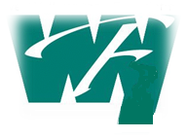
Building Community Together
West Yellowstone Foundation
P.O. Box 255 420 Yellowstone Avenue West Yellowstone, MT 59758 (406) 646-1152
wyfoundation@gmail.com westyellowstonefoundation@gmail.com

2021 Board of Directors

Kevin Flanagan Carol Leasure
Chair Director

Amber Smith Pierre Martineau
Vice Chair Director
Grant Jackson Beth Serniak
Treasurer Director

Pam Sveinson Steffi Siegel
Assistant Treasurer Founder, Director

Denice Sabolsky Buck Taylor
Secretary Director

Marysue Costello Yessika Vega
Director Director

Mary Davis Arnold Siegel
Director Founder (1932-2017)

Erica Kingston
Director

